Class Fundamentals

Class is template for creating objects which defines its state and behavior .Class has methods and variables
Declaring a class:
<Access Modifier >Class <Class Name>
{
Member Variables;
…….
Member functions (){
}
……..
}
Eg.
public class Car
{
String modelcolor;
int modelno;
Sring modelname;
Void showInfo( ){
}
}

Object:
A typical Java program creates many objects, which as you know, interact by invoking methods. Through these object interactions, a program can carry out various tasks.Once an object has completed the work for which it was created, its resources are recycled for use by other objects.
Object Creation :

ClassName objname= new className();
Eg.
Car bmw = new Car();// Constructor

Object and Object Reference:

Rectangle r1 = new Rectangle ();
Rectangle r2 = r1;

- r1 is reference variable which contain the address of Actual Rectangle Object.
- r2 is another reference variable
- r2 is initialized with r1 means – “r1 and r2” both are referring same object , thus it does not create duplicate object , nor does it allocate extra memory.

Creating an object reference:

- We can assign value of reference variable to another reference variable.
- Reference Variable is used to store the address of the variable.
- Assigning Reference will not create distinct copies of Objects.
- All reference variables are referring to same Object.

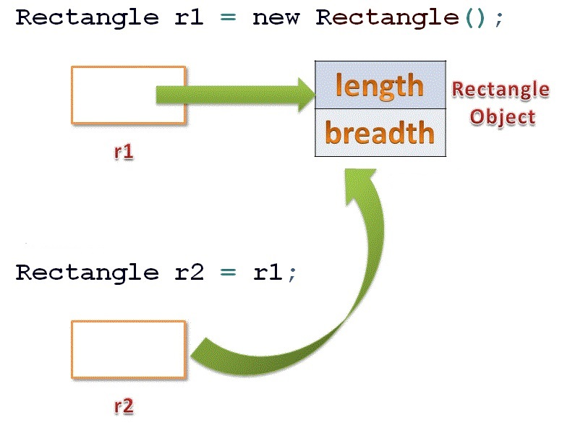

Assigning Object Reference Variables does not -
- Create Distinct Objects.
- Allocate Memory
- Create duplicate Copy
class Rectangle {
double length;
double breadth;
}

Public class RectangleDemo {
public static void main(String args[]) {

Rectangle r1 = new Rectangle();
Rectangle r2 = r1;

r1.length = 10;
r2.length = 20;

System.out.println("Value of R1's Length : " + r1.length);
System.out.println("Value of R2's Length : " + r2.length);

}
}
Output:c:\programfiles\javaprog>javac rectangleDemo.java
c:\programfiles\javaprog>java rectangleDemo
Value of R1's Length : 20.0
Value of R2's Length : 20.0

